## Bike Sharing Dataset

#### Import pandas, numpy, seaborn, matplotlib.pyplot packages

In [2]:

**import** numpy **as** np

**import** pandas **as** pd

**import** matplotlib.pyplot **as** plt

**%**matplotlib inline

**import** seaborn **as** sns

**from** warnings **import** filterwarnings

filterwarnings('ignore')

#### Importing Dataset

In [3]:

df **=** pd.read_csv('Datasets/hour.csv')

df.head()

Out[3]:

|  |  |  |  |  |  |  |  |  |  |  |  |  |  |  |  |  |  |
| --- | --- | --- | --- | --- | --- | --- | --- | --- | --- | --- | --- | --- | --- | --- | --- | --- | --- |
|  | **instant** | **dteday** | **season** | **yr** | **mnth** | **hr** | **holiday** | **weekday** | **workingday** | **weathersit** | **temp** | **atemp** | **hum** | **windspeed** | **casual** | **registered** | **cnt** |
| **0** | 1 | 2011-01-01 | 1 | 0 | 1 | 0 | 0 | 6 | 0 | 1 | 0.24 | 0.2879 | 0.81 | 0.0 | 3 | 13 | 16 |
| **1** | 2 | 2011-01-01 | 1 | 0 | 1 | 1 | 0 | 6 | 0 | 1 | 0.22 | 0.2727 | 0.80 | 0.0 | 8 | 32 | 40 |
| **2** | 3 | 2011-01-01 | 1 | 0 | 1 | 2 | 0 | 6 | 0 | 1 | 0.22 | 0.2727 | 0.80 | 0.0 | 5 | 27 | 32 |
| **3** | 4 | 2011-01-01 | 1 | 0 | 1 | 3 | 0 | 6 | 0 | 1 | 0.24 | 0.2879 | 0.75 | 0.0 | 3 | 10 | 13 |
| **4** | 5 | 2011-01-01 | 1 | 0 | 1 | 4 | 0 | 6 | 0 | 1 | 0.24 | 0.2879 | 0.75 | 0.0 | 0 | 1 | 1 |

In [48]:

df.tail()

Out[48]:

|  |  |  |  |  |  |  |  |  |  |  |  |  |  |  |  |  |  |
| --- | --- | --- | --- | --- | --- | --- | --- | --- | --- | --- | --- | --- | --- | --- | --- | --- | --- |
|  | **instant** | **dteday** | **season** | **yr** | **mnth** | **hr** | **holiday** | **weekday** | **workingday** | **weathersit** | **temp** | **atemp** | **hum** | **windspeed** | **casual** | **registered** | **cnt** |
| **17374** | 17375 | 2012-12-31 | 1 | 1 | 12 | 19 | 0 | 1 | 1 | 2 | 0.26 | 0.2576 | 0.60 | 0.1642 | 11 | 108 | 119 |
| **17375** | 17376 | 2012-12-31 | 1 | 1 | 12 | 20 | 0 | 1 | 1 | 2 | 0.26 | 0.2576 | 0.60 | 0.1642 | 8 | 81 | 89 |
| **17376** | 17377 | 2012-12-31 | 1 | 1 | 12 | 21 | 0 | 1 | 1 | 1 | 0.26 | 0.2576 | 0.60 | 0.1642 | 7 | 83 | 90 |
| **17377** | 17378 | 2012-12-31 | 1 | 1 | 12 | 22 | 0 | 1 | 1 | 1 | 0.26 | 0.2727 | 0.56 | 0.1343 | 13 | 48 | 61 |
| **17378** | 17379 | 2012-12-31 | 1 | 1 | 12 | 23 | 0 | 1 | 1 | 1 | 0.26 | 0.2727 | 0.65 | 0.1343 | 12 | 37 | 49 |

**It is a Regression Problem - the Dependent variable is cnt(ie, count of total rental bikes)**

* By viewing Data we can say on Working day the count of total rental bikes(including both casual and registered) is high
* **Shape of Dataset**

In [49]:

df.shape

Out[49]:

(17379, 17)

* **The dataset has total 17379 rows & 17 attributes**
* **Checking Information of Dataset**

In [50]:

df.info()

<class 'pandas.core.frame.DataFrame'>  
RangeIndex: 17379 entries, 0 to 17378  
Data columns (total 17 columns):  
 # Column Non-Null Count Dtype   
--- ------ -------------- -----   
 0 instant 17379 non-null int64   
 1 dteday 17379 non-null object   
 2 season 17379 non-null int64   
 3 yr 17379 non-null int64   
 4 mnth 17379 non-null int64   
 5 hr 17379 non-null int64   
 6 holiday 17379 non-null int64   
 7 weekday 17379 non-null int64   
 8 workingday 17379 non-null int64   
 9 weathersit 17379 non-null int64   
 10 temp 17379 non-null float64  
 11 atemp 17379 non-null float64  
 12 hum 17379 non-null float64  
 13 windspeed 17379 non-null float64  
 14 casual 17379 non-null int64   
 15 registered 17379 non-null int64   
 16 cnt 17379 non-null int64   
dtypes: float64(4), int64(12), object(1)  
memory usage: 2.3+ MB

* Dataset has 4 Float columns, 12 integer columns and 1 object (string) Columns

## EDA

**Plotting Histogram**

In [52]:

df.hist(figsize**=**(10,10))

plt.show()

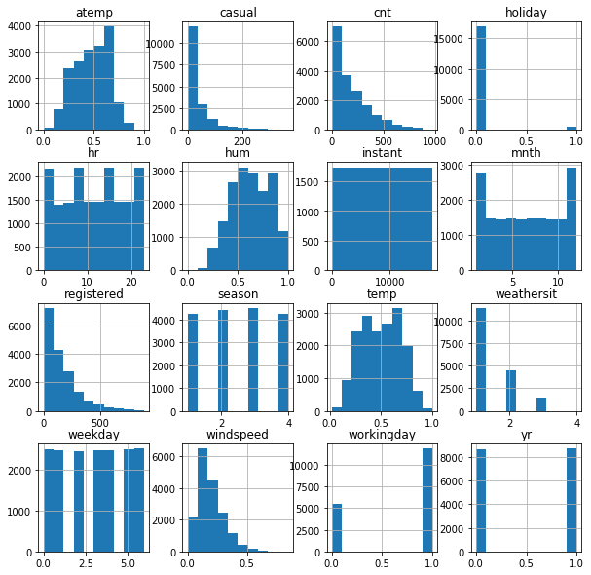

### Inference from Histogram:

* Holiday, Season, weathersit, weekday, workingday, yr are Categorical Variables which are in Encoded format
* instant is irrelevent column

### Checking outliers

In [53]:

col **=** [ 'season', 'yr', 'mnth', 'hr', 'holiday', 'weekday',

'workingday', 'weathersit', 'temp', 'atemp', 'hum', 'windspeed',

'casual', 'registered', 'cnt']

**for** i **in** col:

sns.boxplot(df[i])

plt.show()

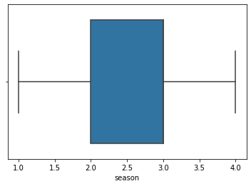

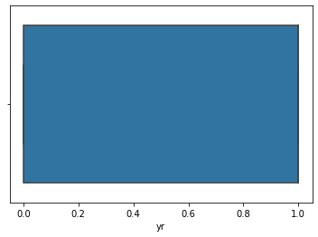

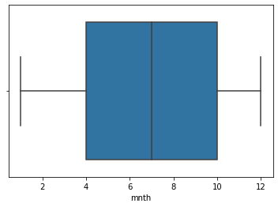

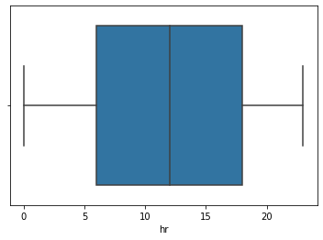

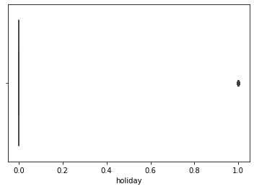

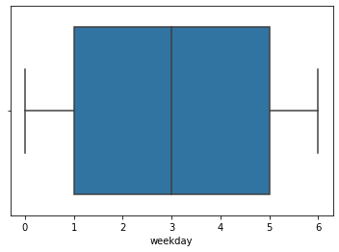

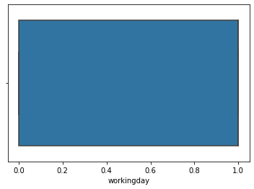

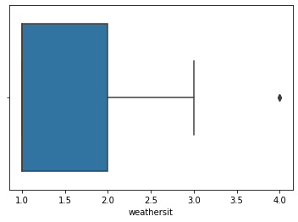

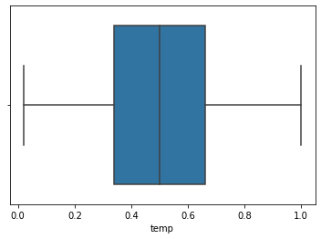

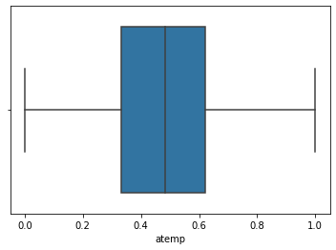

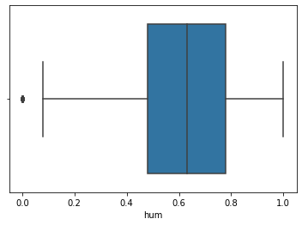

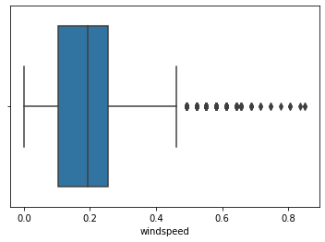

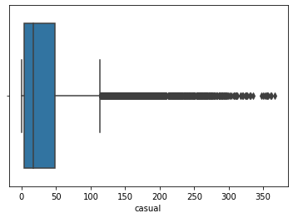

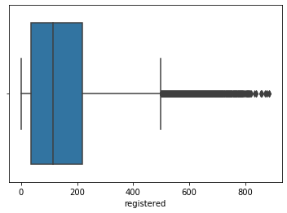

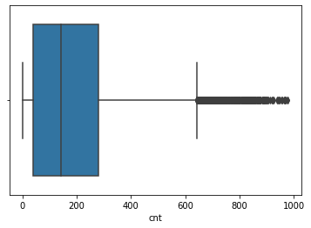

* There is single outlier in weathersit, hum
* There are moderate outliers in windspeed
* There are many outliers in casual, registered, cnt
* Others have no outlier

### checks Distribution

In [54]:

colm **=** [ 'season', 'yr', 'mnth', 'hr', 'weekday',

'workingday', 'weathersit', 'temp', 'atemp', 'hum', 'windspeed',

'casual', 'registered', 'cnt']

**for** col **in** colm:

sns.distplot(df[col])

plt.show()

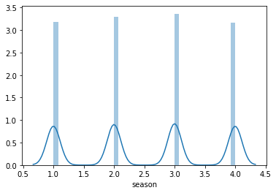

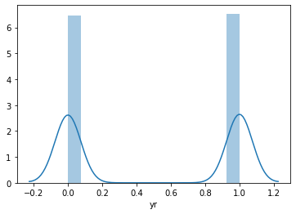

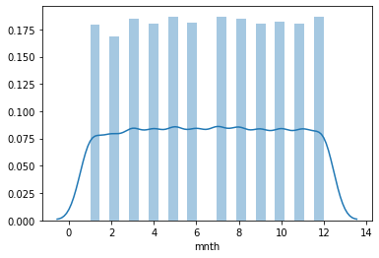

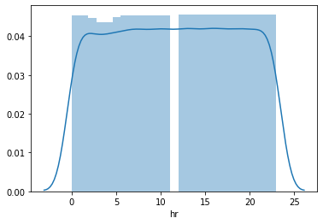

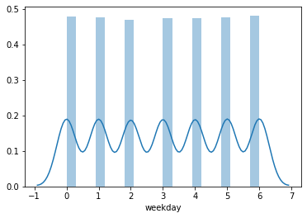

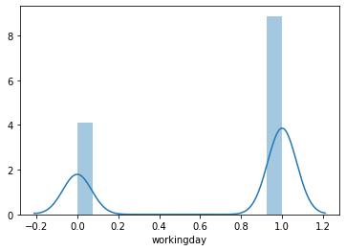

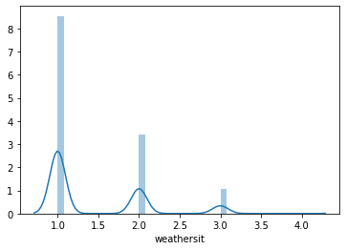

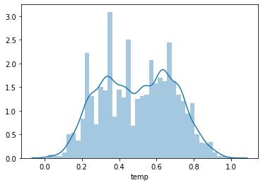

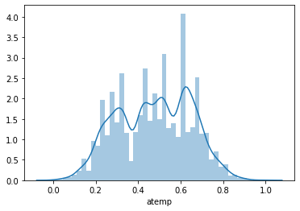

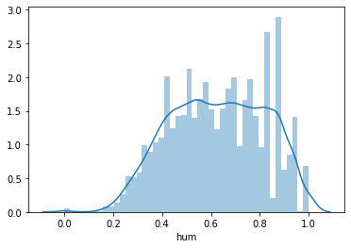

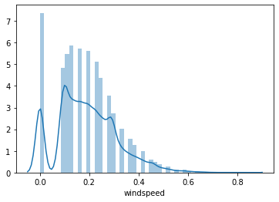

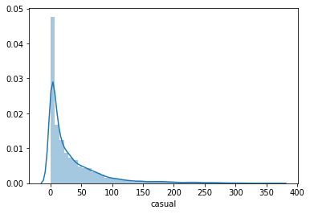

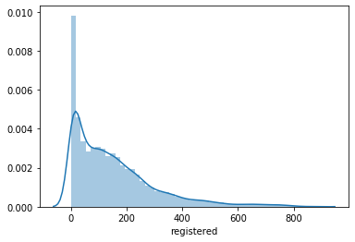

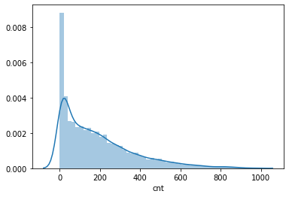

Type *Markdown* and LaTeX: ??2

### Analysis

In [55]:

df['season'].value_counts()

Out[55]:

3 4496  
2 4409  
1 4242  
4 4232  
Name: season, dtype: int64

In [56]:

df['season'].value_counts().plot(kind**=**'pie', autopct **=** "%1.0f%%")

Out[56]:

<matplotlib.axes._subplots.AxesSubplot at 0x1def591d588>

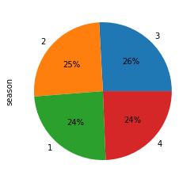

In [57]:

sns.barplot(df['season'], df['cnt'])

Out[57]:

<matplotlib.axes._subplots.AxesSubplot at 0x1def5984f08>

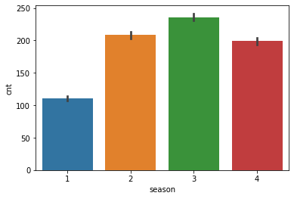

In [58]:

sns.pointplot(df['season'], df['cnt'])

Out[58]:

<matplotlib.axes._subplots.AxesSubplot at 0x1def59e8bc8>

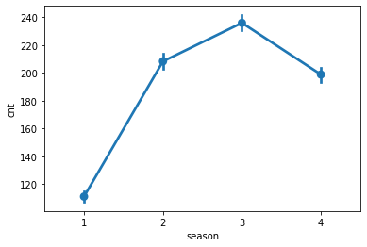

In [59]:

df['yr'].value_counts()

Out[59]:

1 8734  
0 8645  
Name: yr, dtype: int64

In [60]:

df['yr'].value_counts().plot(kind**=**'pie', autopct **=** "%1.0f%%")

Out[60]:

<matplotlib.axes._subplots.AxesSubplot at 0x1def5a507c8>

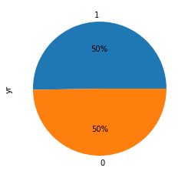

In [61]:

sns.pointplot(df['yr'], df['cnt'])

Out[61]:

<matplotlib.axes._subplots.AxesSubplot at 0x1def5a66788>

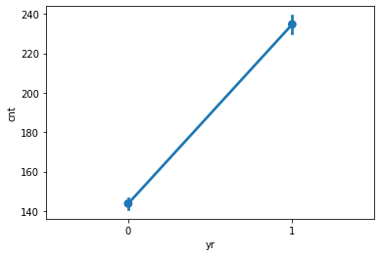

In [62]:

df['mnth'].value_counts()

Out[62]:

7 1488  
5 1488  
12 1483  
8 1475  
3 1473  
10 1451  
6 1440  
11 1437  
9 1437  
4 1437  
1 1429  
2 1341  
Name: mnth, dtype: int64

In [63]:

df['mnth'].value_counts().plot(kind**=**'pie', autopct **=** "%1.0f%%")

Out[63]:

<matplotlib.axes._subplots.AxesSubplot at 0x1def5b0a208>

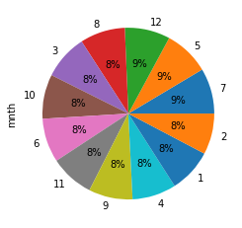

In [64]:

sns.barplot(df['mnth'], df['cnt'])

Out[64]:

<matplotlib.axes._subplots.AxesSubplot at 0x1def5b9eb48>

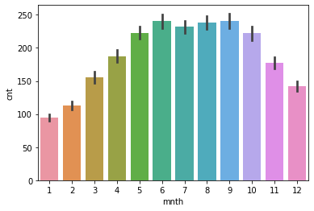

In [65]:

sns.pointplot(df['mnth'], df['cnt'])

Out[65]:

<matplotlib.axes._subplots.AxesSubplot at 0x1def5c38c08>

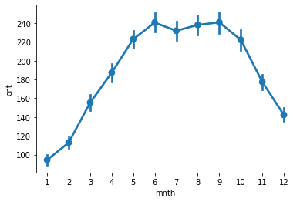

In [66]:

df['holiday'].value_counts()

Out[66]:

0 16879  
1 500  
Name: holiday, dtype: int64

In [67]:

df['holiday'].value_counts().plot(kind**=**'pie', autopct **=** "%1.0f%%")

Out[67]:

<matplotlib.axes._subplots.AxesSubplot at 0x1def5ce0248>

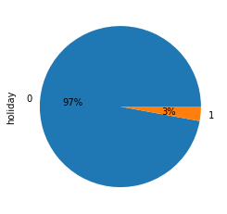

In [68]:

sns.barplot(df['holiday'], df['cnt'])

Out[68]:

<matplotlib.axes._subplots.AxesSubplot at 0x1def5c4d248>

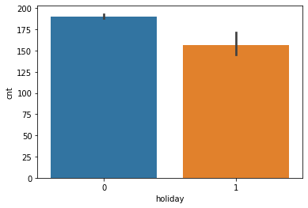

In [69]:

sns.pointplot(df['holiday'], df['cnt'])

Out[69]:

<matplotlib.axes._subplots.AxesSubplot at 0x1def5ce9fc8>

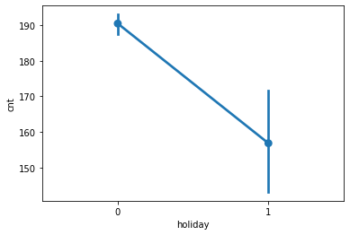

In [70]:

df['weekday'].value_counts()

Out[70]:

6 2512  
0 2502  
5 2487  
1 2479  
3 2475  
4 2471  
2 2453  
Name: weekday, dtype: int64

In [71]:

df['weekday'].value_counts().plot(kind**=**'pie', autopct **=** "%1.0f%%")

Out[71]:

<matplotlib.axes._subplots.AxesSubplot at 0x1def58a74c8>

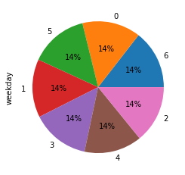

In [72]:

sns.barplot(df['weekday'], df['cnt'])

Out[72]:

<matplotlib.axes._subplots.AxesSubplot at 0x1def4835ec8>

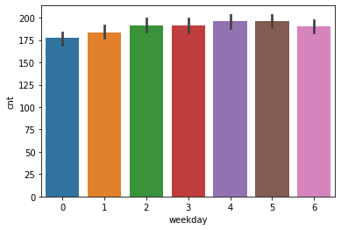

In [73]:

sns.pointplot(df['weekday'], df['cnt'])

Out[73]:

<matplotlib.axes._subplots.AxesSubplot at 0x1def5d9cf48>

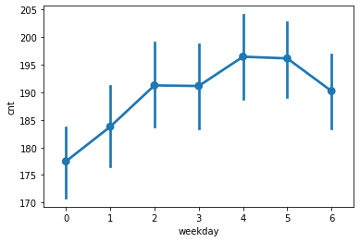

In [74]:

df['workingday'].value_counts()

Out[74]:

1 11865  
0 5514  
Name: workingday, dtype: int64

In [75]:

df['workingday'].value_counts().plot(kind**=**'pie', autopct **=** "%1.0f%%")

Out[75]:

<matplotlib.axes._subplots.AxesSubplot at 0x1def3e2b8c8>

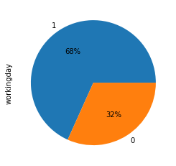

In [76]:

sns.pointplot(df['workingday'], df['cnt'])

Out[76]:

<matplotlib.axes._subplots.AxesSubplot at 0x1def21ae288>

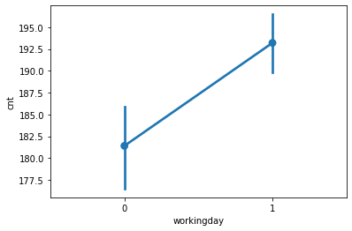

In [77]:

sns.barplot(df['workingday'], df['cnt'])

Out[77]:

<matplotlib.axes._subplots.AxesSubplot at 0x1def3e25848>

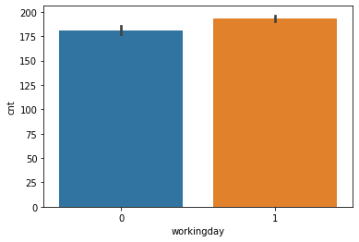

In [78]:

plt.figure(figsize**=**(15,10))

sns.heatmap(df.corr(), annot **=** **True**)

Out[78]:

<matplotlib.axes._subplots.AxesSubplot at 0x1deef5b8148>

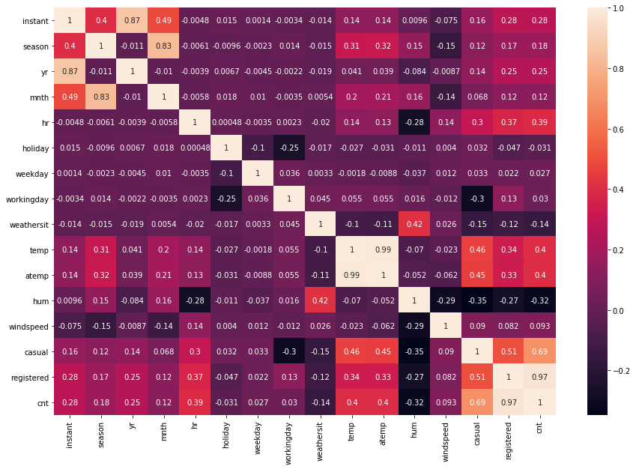

Important Varibale by correlation matrix is:

* registered, casual, hum, atemp, temp, hr is Important variable for predicting cnt

## Data preprocessing

Pre-processing techniques include:

* 1.Handling Missing Data
* 2.Removing Outliers
* 3.Encoding Categorical Text Variables
* 4.Feature Scaling

#### Check Null Values

In [51]:

df.isnull().sum()

Out[51]:

instant 0  
dteday 0  
season 0  
yr 0  
mnth 0  
hr 0  
holiday 0  
weekday 0  
workingday 0  
weathersit 0  
temp 0  
atemp 0  
hum 0  
windspeed 0  
casual 0  
registered 0  
cnt 0  
dtype: int64

* There is no Null Values

#### Now droping irrelevent columns

In [4]:

df **=** df.drop(['instant','dteday'], axis**=**1)

df.head()

Out[4]:

|  |  |  |  |  |  |  |  |  |  |  |  |  |  |  |  |
| --- | --- | --- | --- | --- | --- | --- | --- | --- | --- | --- | --- | --- | --- | --- | --- |
|  | **season** | **yr** | **mnth** | **hr** | **holiday** | **weekday** | **workingday** | **weathersit** | **temp** | **atemp** | **hum** | **windspeed** | **casual** | **registered** | **cnt** |
| **0** | 1 | 0 | 1 | 0 | 0 | 6 | 0 | 1 | 0.24 | 0.2879 | 0.81 | 0.0 | 3 | 13 | 16 |
| **1** | 1 | 0 | 1 | 1 | 0 | 6 | 0 | 1 | 0.22 | 0.2727 | 0.80 | 0.0 | 8 | 32 | 40 |
| **2** | 1 | 0 | 1 | 2 | 0 | 6 | 0 | 1 | 0.22 | 0.2727 | 0.80 | 0.0 | 5 | 27 | 32 |
| **3** | 1 | 0 | 1 | 3 | 0 | 6 | 0 | 1 | 0.24 | 0.2879 | 0.75 | 0.0 | 3 | 10 | 13 |
| **4** | 1 | 0 | 1 | 4 | 0 | 6 | 0 | 1 | 0.24 | 0.2879 | 0.75 | 0.0 | 0 | 1 | 1 |

* There is No Object variable so, no need for label encoding/one hot encoding

### Spliting Data into x and y

In [27]:

x **=** df.drop(['cnt'], axis**=**1)

x.head()

Out[27]:

|  |  |  |  |  |  |  |  |  |  |  |  |  |  |  |
| --- | --- | --- | --- | --- | --- | --- | --- | --- | --- | --- | --- | --- | --- | --- |
|  | **season** | **yr** | **mnth** | **hr** | **holiday** | **weekday** | **workingday** | **weathersit** | **temp** | **atemp** | **hum** | **windspeed** | **casual** | **registered** |
| **0** | 1 | 0 | 1 | 0 | 0 | 6 | 0 | 1 | 0.24 | 0.2879 | 0.81 | 0.0 | 3 | 13 |
| **1** | 1 | 0 | 1 | 1 | 0 | 6 | 0 | 1 | 0.22 | 0.2727 | 0.80 | 0.0 | 8 | 32 |
| **2** | 1 | 0 | 1 | 2 | 0 | 6 | 0 | 1 | 0.22 | 0.2727 | 0.80 | 0.0 | 5 | 27 |
| **3** | 1 | 0 | 1 | 3 | 0 | 6 | 0 | 1 | 0.24 | 0.2879 | 0.75 | 0.0 | 3 | 10 |
| **4** | 1 | 0 | 1 | 4 | 0 | 6 | 0 | 1 | 0.24 | 0.2879 | 0.75 | 0.0 | 0 | 1 |

In [28]:

y **=** df.iloc[:,**-**1:]

y.head()

Out[28]:

|  |  |
| --- | --- |
|  | **cnt** |
| **0** | 16 |
| **1** | 40 |
| **2** | 32 |
| **3** | 13 |
| **4** | 1 |

### Spliting data into test and training set

In [29]:

**from** sklearn.model_selection **import** train_test_split

X_train, X_test, y_train, y_test **=** train_test_split(x, y, test_size**=**0.30)

In [30]:

print("Dataset shape:", df.shape)

print("Input Features shape: ", X_train.shape, y_train.shape)

print("Output Features shape: ", X_test.shape, y_test.shape)

Dataset shape: (17379, 15)  
Input Features shape: (12165, 14) (12165, 1)  
Output Features shape: (5214, 14) (5214, 1)

### Applying Linear Regression

In [31]:

**from** sklearn.linear_model **import** LinearRegression

lin **=** LinearRegression()

#### Fitting model

In [32]:

lin.fit(X_train,y_train)

Out[32]:

LinearRegression()

#### Predicting values

In [33]:

pred **=** lin.predict(X_test)

In [34]:

pred

Out[34]:

array([[391.],  
 [330.],  
 [ 5.],  
 ...,  
 [ 8.],  
 [ 30.],  
 [300.]])

#### Finding score

In [35]:

**from** sklearn.metrics **import** r2_score

In [36]:

r2_score(y_test, pred)

Out[36]:

1.0

#### Ploting graph for test values

In [37]:

sns.regplot(y_test,pred)

Out[37]:

<matplotlib.axes._subplots.AxesSubplot at 0x1d155b9c3a0>

